**Travel UK Lunar New Year 7 days 6 nights depart from Hanoi 2020**

*Attention:*

-Departure: Ha Noi.

-Time: 7 days 6 nights.

-Vehicle: planes.

-Price: 69990000VND.

-Image:

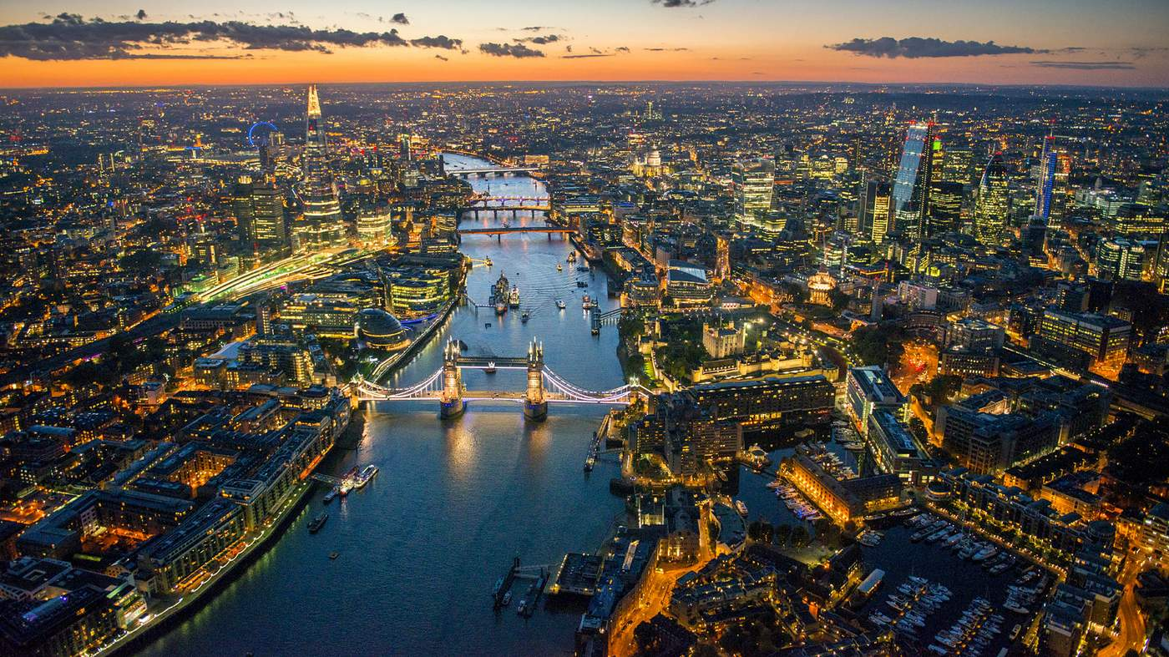

**I.Introduce:**

Travel UK Lunar New Year 2020. Another spring is coming, another New Year is near. Family members eagerly await the Lunar New Year in the jubilant atmosphere of the big festival. Spring is coming soon, plan a meaningful spring trip now. Traveling to the Vietnamese Lunar New Year with Vietnam Tourism will be a wonderful, beautiful misty journey for you. Let's Travel Vietnam discover the beautiful UK with these interesting destinations:

• Only in a journey you have the opportunity to explore the two countries: "Buy a British tour, give a Brunei premium tour". Visit Brunei, the country with massive mosques.

• Cotswolds a small town with very interesting stone houses.

• Stratford Upon Avon is the home of famous writer William Shakespeare.

• London city of arrogance and modernity.

• Old Trafford Stadium is dubbed the theater of dreams.

• Oxford University Village is famous and ancient.

**II.** **Tour schedule:**

**1.Day 1:**

**VIETNAM - BRUNEI - LONDON** _____________________________________________________________________

You focus at the airport, HDV Travel Vietnam company helps you do aviation procedures for flights to Brunei, then connecting flights to London BI 384 (20:35 - 23:30) & BI 003 (00:15 - 06: 50). You eat, rest on the plane._____________________________________________________________________

**2.Day 2:**

**LONDON - COTSWOLDS - STRATFORD UPON AVON (Lunch, dinner)** _____________________________________________________________________

06:50 Delegation to London. Bus tour to visit the Cotswolds - a complex of beautiful small towns and pleasant villages with extremely strange and unique stone houses. The delegation continued the journey to Stratford - upon Avon - where the great playwright William Shakespeare was born and also his final resting place. Here, the delegation took photos at the Holy Trinity Church, Nash's house - the house of Shakespeare's grandson. Next to Nash's house, there was a fairly large and beautiful flower garden, in the middle of the garden there was a stele clearly stating: This was once a Shakespeare's house.

Dinner, check in and overnight in Straford. _____________________________________________________________________

**3.Day 3:**

**STRATFORD UPON AVON - MANCHESTER** _____________________________________________________________________ After breakfast, check out hotel room. Depart for Manchester - the second largest city in England and was dubbed the "Capital of Northern England".

Group lunch at Manchester. Then visit:

Manchester Theater

China Town area

Albert Square

Manchester City Hall

Manchester Cathedral - is a medieval church, had ten bells in the church tower was cast in 1925 by Gillett & Johnston and rang the bell on Sunday mornings and special occasions.

You experience the discovery tour inside the Old Trafford Stadium - "Theater of Dreams" - is a famous football stadium at Old Trafford, Greater Manchester, United Kingdom and is the home of the sentence. Manchester United FC football club with a capacity of 75,635 people. Old Trafford is the 2nd largest football stadium in the United Kingdom after Wembley, and 9th in Europe. _____________________________________________________________________

**4.Day 4:**

**MANCHESTER - OXFORD - LONDON (Ăn ba bữa)** _____________________________________________________________________

Đoàn dùng điểm tâm sáng, làm thủ tục trả phòng, khởi hành đến với Thành phố Oxford - Cả trung tâm thành phố Oxford là một làng Đại học với 36 trường trực thuộc.

Đến nơi, đoàn ăn trưa sau đó trãi nghiệm 1 vòng city tour  tham quan (chụp hình bên ngoài các điểm): Khu vực trung tâm thành phố Carfax, Nhà thờ, các công trình Đại học và bảo tàng là ba điều không nên bỏ qua nếu có dịp ghé Oxford.

* Có thể kể tới đầu tiên là Nhà thờ Saint Michael (thế kỷ 11) và Nhà thờ Saint Mary the Virgin (thế kỷ 13)
* Thư viện Bodleian
* Nhà hát Sheldonian (1664-1669).
* Bảo tàng Ashmolean - bảo tàng đại học đầu tiên trên thế giới chứa đựng các bộ sưu tập nghệ thuật và khảo cổ xuất sắc của Đại học Oxford.
* Nếu là một fan lớn của Harry Potter, đừng bỏ qua cơ hội thăm ngôi trường đại học Christ Church (chụp hình bên ngoài)
* Nhà thờ Santa Maria,…

Sau đó đoàn khởi hành về lại thủ đô London. Đến London, đoàn ăn tối, nhận phòng khách sạn nghỉ ngơi.

_____________________________________________________________________

**5.Day 5:**

LONDON CITY TOUR - BRUNEI (Breakfast, lunch, dinner on board) ____________________________________________________________________ After breakfast at the hotel, the bus takes the group to take pictures outside some of London's typical works:

The Palace of Westminster or the London Parliament Building is where the House of Representatives holds meetings

Big Ben clock tower

Buckingham Palace, 10 Downing Street - is the most famous address in London and is also the residence of the British Prime Minister

Parliament square

Tower Bridge - this work combines a suspension bridge with a lift bridge across the River Thames, The Shard or Shard London Bridge or Shard of Glass is a skyscraper in Southwark.

Lunch then continue shopping tour programs in major shopping areas of London such as Burlington Arcade, Regent Street, ...

Depart to airport for flight to Brunei BI 004 (20:10 - 17: 25 + 1). Dinner and rest on the plane. _____________________________________________________________________

**6.Day 6:**

**BRUNEI - KHÁM PHÁ BRUNEI VỀ ĐÊM** _____________________________________________________________________

17:25 Đoàn đến Brunei – đất nước với các thánh đường hồi giáo đồ sộ. Xe đưa quý khách tham quan một số địa điểm nổi tiếng ở Brunei như:

Thánh đường Hồi giáo Jame Asr Mosque - đền thờ Thánh Ali và Thánh Jame của đạo Hồi tại Brunie

Cung điện Israna Nurul Iman - theo tiếng Ả Rập nghĩa là “Cung điện ánh sáng của các vị Thánh”. Đây chính là Hoàng cung lớn nhất thế giới hiện nay (tham quan chụp hình bên ngoài),…

Sau khi dùng bữa tối, Đoàn tham quan và mua sắm tại chợ đêm ngay thủ đô Bandar Seri Begawan. Nghỉ đêm tại khách sạn 4* Brunei.

_____________________________________________________________________

**7.Day 7:**

**BRUNEI – VIETNAM**

_____________________________________________________________________

Have breakfast and check out. Bus transfer to airport for flight to Vietnam BI 381 (12:30 - 13:25).

13:25 Arriving at the airport, after going to Vietnam immigration procedures & taking back your personal luggage, the Head of the Vietnam Tourism Group says goodbye to you. End of tour. _____________________________________________________________________

**III.** **INCLUDED AND TERMS:**

**TOUR PRICE INCLUDES:**

Return international air ticket Royal Brunei Airlines: Ho Chi Minh City - Brunei - London // London - Brunei - Ho Chi Minh City.

Air tickets domestic routes Hanoi - Ho Chi Minh City.

UK visa application fee, invitation fee & translation fee.

Taxes, fuel surcharges, security fees, airport fees 2 countries.

4-star hotel & Brunei standard double room. In the school you travel alone (male or female solo) 3-room room (triple room) will be arranged as needed. In case there are no other guests (alone) to pair, please pay the surcharge for a single room.

Only 1 Tour guide (team leader) from Vietnam will follow the group during the tour (departure for more than 10 guests).

Visiting shuttle program.

Gift Travel Vietnam.

International travel insurance.

**TOUR PRICE DO NOT INCLUDE:**

Passport valid for at least 06 months up to the date of return to Vietnam.

Tips for Vietnamese Guides to accompany the delegation throughout the tour and driver in the UK.

Personal expenses, excess baggage and expenses incurred outside the program.

Cost of moving dates, changing itineraries (changing routes), upgrading flight tickets.

Surcharge single room.